# 

Product Subcategory Model

Master Data Services

Chapter 6 of the book **The Microsoft Data Warehouse Toolkit for SQL Server 2008 R2**, 2011 (MDWT) walks through a very simple example of building a Master Data Services model. The scenario describes a DW team that wants to add some attributes, and an alternative hierarchy, to the product dimension. Most of the product dimension is maintained from the transaction database (AdventureWorks), and the additional attributes do not have a real system to support them. SQL Server MDS is an appropriate platform on which to build that application.

The example MDS model is painfully simple. In some ways that makes it a good starting point, as the models that Microsoft provides are a little more complicated.

# To Get Started

* Install SQL Server 2008R2, including Master Data Services. The best instructions are available from MSDN at http://msdn.microsoft.com/en-us/sqlserver/ff943581.aspx.
* Once you unzip the .pkg file you can deploy it to your MDS system using the Model Deployment Wizard. For more information about using the Model Deployment Wizard, see “Deploying Models (Master Data Services)” (http://msdn.microsoft.com/en-us/library/ff486956(SQL.105).aspx) in SQL Server Books Online.

# Exploring the Model

There is so little to the model that you could easily recreate it by hand in a few minutes. The model starts at the subcategory level, as illustrated here:

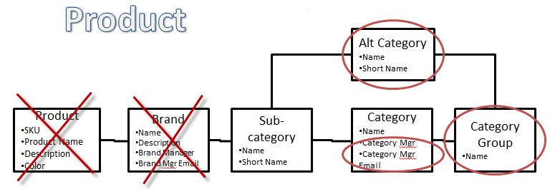

There are 37 rows. The book contains a simple SQL script for importing the leaf level rows into the subcategory level. You can easily write a similar script for adding the category (which comes from AdventureWorks). I typed the additional attributes in by hand, as they don’t exist in AdventureWorks.

Creating even this very simple model from scratch and doing a little bit of data importing and data entry, will teach you different things than exploring an existing (more complicated) model. Both are worthy exercises.